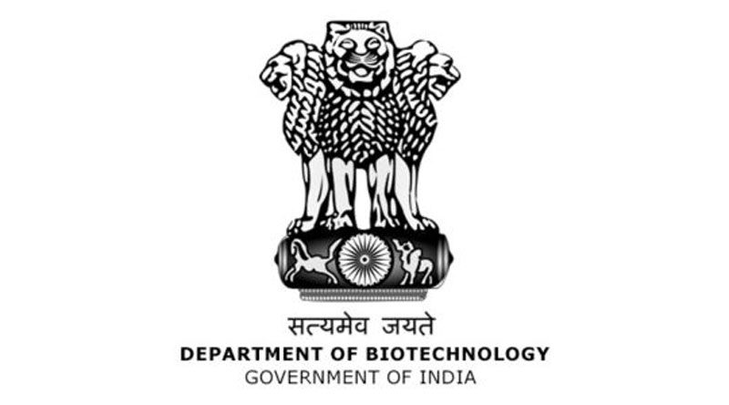

35th Foundation Day of DBT
26th February 2021, 10:30 A.M. to 01:30 P.M.
Time | Schedule | Speakers
Webinar on "35 years of Biotechnology Growth in India - An exciting journey"
10:30 am -10:35 am | Introduction | Dr. Meenakshi Munshi, Adviser, DBT
10:35 am – 10.45 am | Welcome Address | Dr Renu Swarup,  Secretary, DBT
10:45 am – 10:55 am | Address | Prof. K. Vijay Raghavan  PSA to Govt. of India, and Former Secretary, DBT
10:55 am – 11:05 am | Building a Strong and Vibrant Ecosystem | Prof. G. Padmanaban, Honorary Professor, IISc, Bangalore
11:05 am -11:15 am | Building a Strong Research Foundation | Prof. P. Balaram,  Honorary Professor, IISc, Bangalore
11:15 am -11:25 am | Building a Strong Neuroscience Network | Prof. Vijayalakshmi Ravindranath,  Centre for Neuroscience, IISc, Bangalore
11:25 am -11:35 am | Our Journey of Plant Genomics | Dr. Akhilesh Tyagi,  Former Director, DBT-NIPGR, New Delhi
11:35 am -11:45 am | Address | Dr. Manju Sharma  Former Secretary, DBT
11:45 am -11:55 am | Our Journey of Building a Vibrant Startup Ecosystem | Ms. Deepanwita Chattopadhyay, Chairman & CEO at IKP Knowledge Park, Hyderabad
11:55 am – 12:30 pm | Open interaction
Award function to be presided over by the Hon’ble Minister
12:30 pm-01:30 pm | Arrival of chief guest  Welcome address by  Opening Address  About the Awards/Awardee  Presentation of BRITE (Biotechnology Research Innovation and Technology Excellence)  DBT fight against COVID: From Virus to Vaccine- release of an e-book  Address by chief guest  Vote of Thanks | Dr. Meenakshi Munshi, Adviser, DBT  Dr. Renu Swarup, Secretary, DBT  Dr Deo Prakash Chaturvedi, Sci-C, DBT  Dr. Harsh Vardhan, Hon’ble Minister of Science & Technology, MoH&FW and Earth Sciences  Dr. Harsh Vardhan, Hon’ble Minister of Science & Technology, MoH&FW and Earth Sciences  Dr. Harsh Vardhan, Hon’ble Minister of Science & Technology, MoH&FW and Earth Sciences  Dr. Vaishali Panjabi, Sci-E, DBT

